SIGCCSE In-Cooperation

Start at http://cms.acm.org/incoop/cms_incoop.cfm

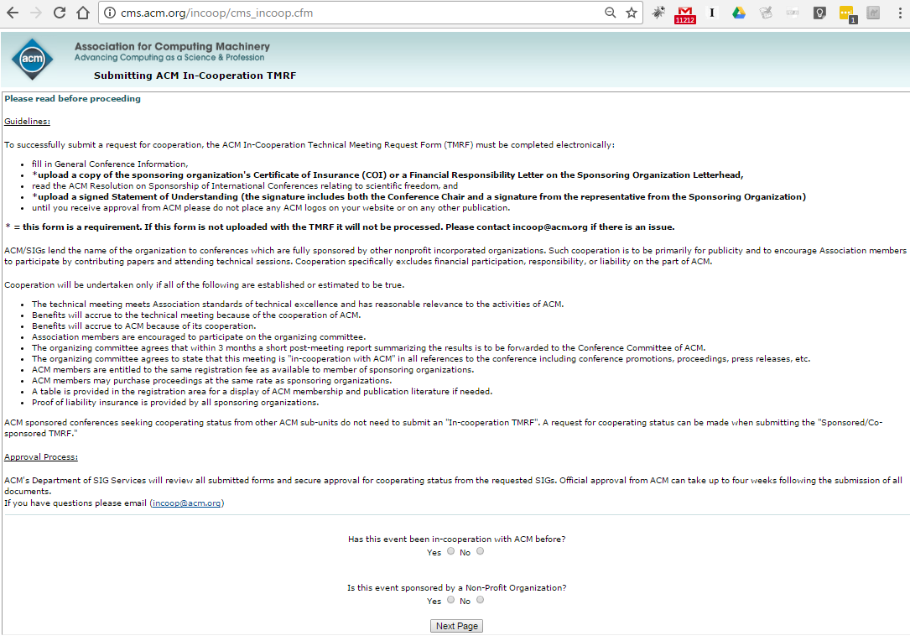

Choose Yes for both and select Next Page
Enter CCSC and year (ie. 2017) and select Continue

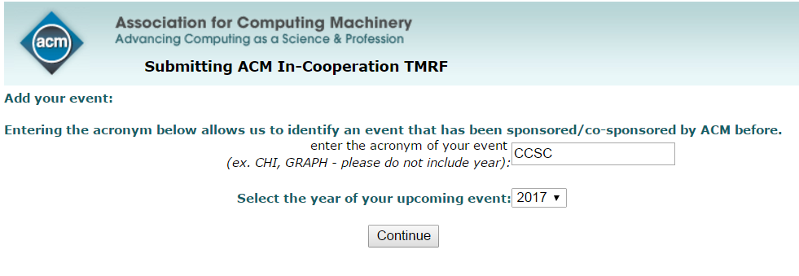
List of CCSC conferences will appear. Select previous conference to update (ie. CCSC MW ‘16 to enter new data for CCSC MW ‘17) and new page will appear to enter data.

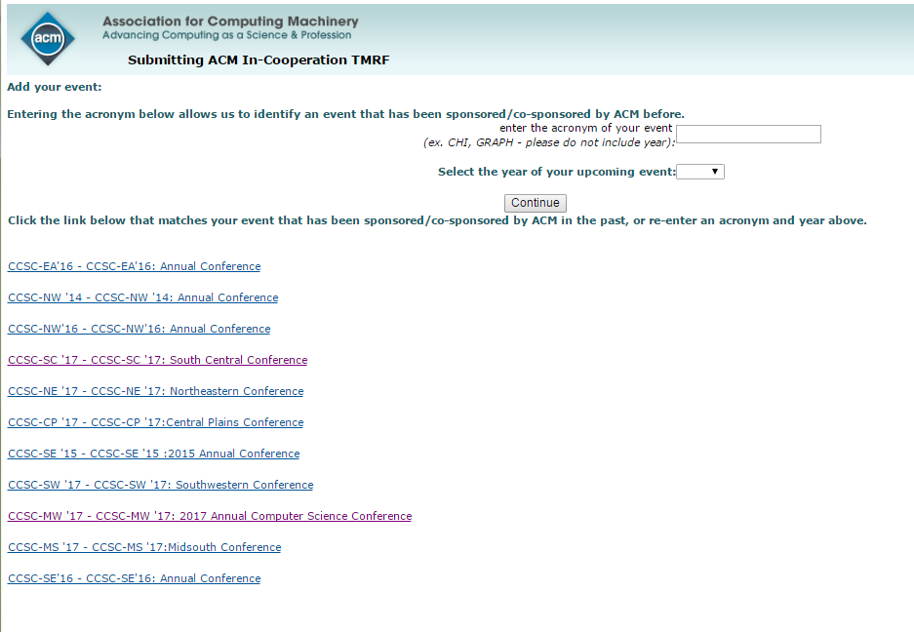

Enter Event Title, Conference, 12 month frequency, start date, stop date, and conference URL.

Note: use Event Title format CCSC-MW '17: 2017 Annual Computer Science Conference

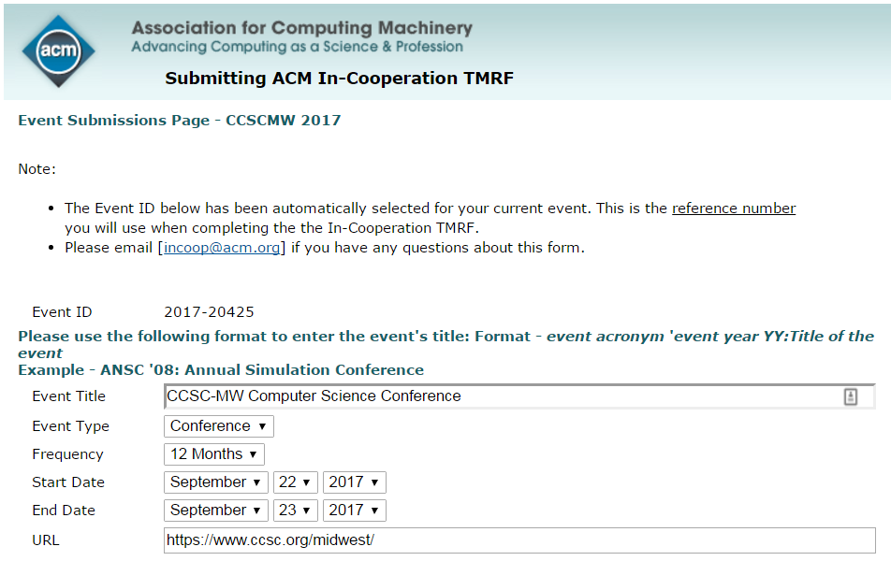

Location and Financial Responsibility

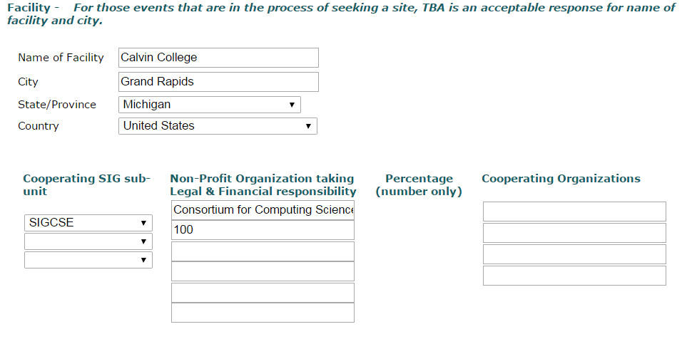
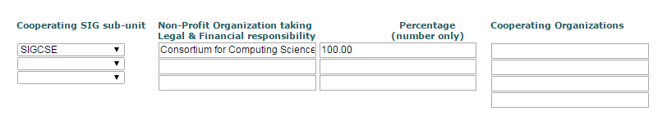

Anticipated Attendees, session, papers, income, expenses

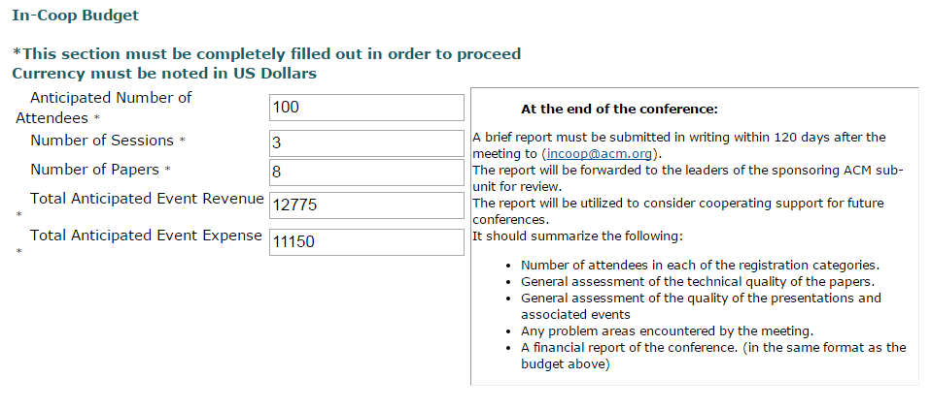

Event Proceedings

Consortium for Computing Sciences in Colleges
5 Maple Street, Walton, NY 13856
jmeinke@frontiernet.net
607-865-4017
A wide variety of topics relating to Computer Science and Computer Science Education

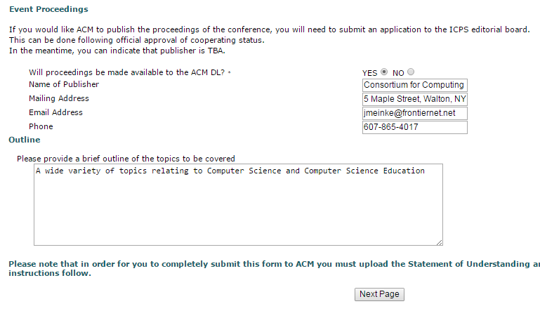

Two pages of Acknowledgments
Page #1

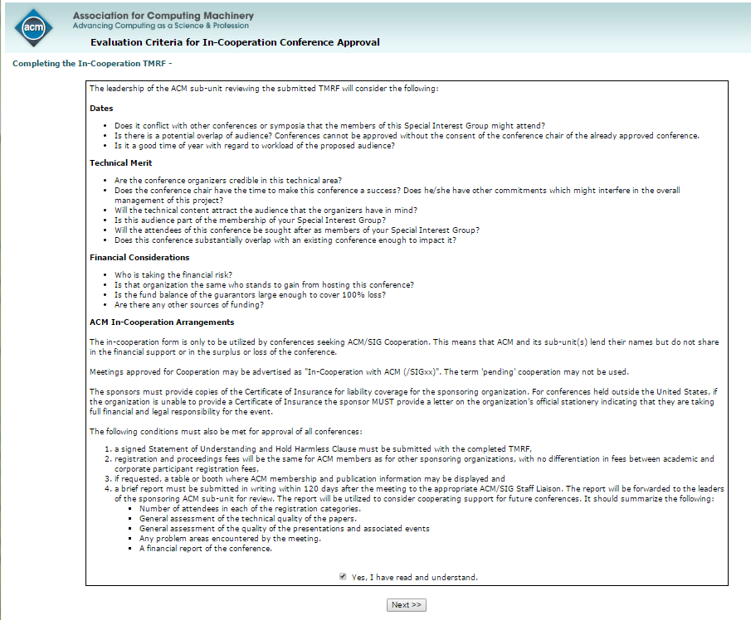

Page #2

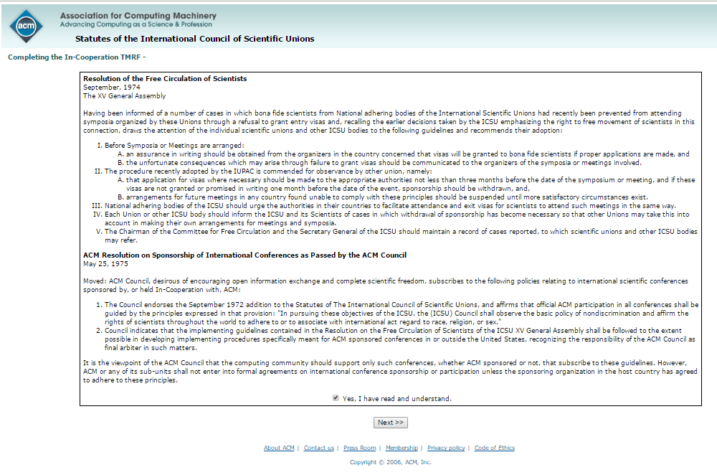

Chair, and Program Chair (ie. Papers) (Note: easier if you have ACM # ie. Lehman is 4218624)

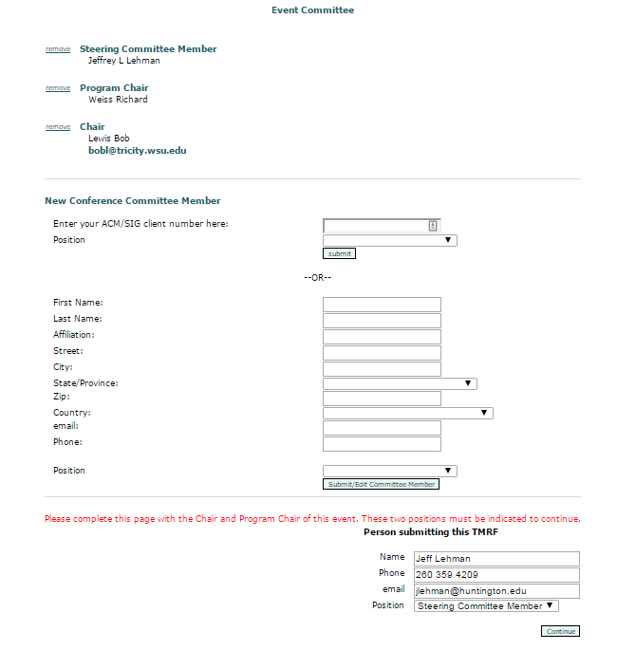

Upload
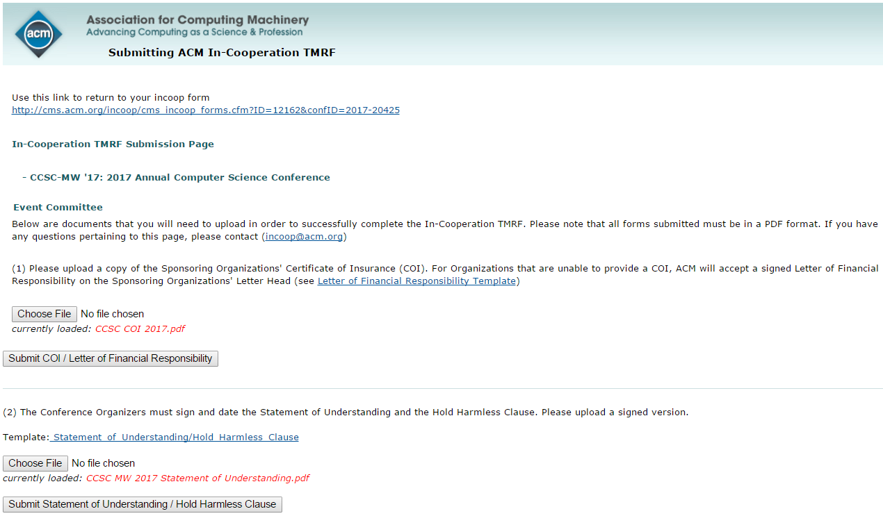

Note from Will Mitchell (May 25, 2017)
No, we have never sent in the post report and I have been doing the forms for about 15 years.
I hope that Scott passed on the documentation I sent him--if not I can forward all of it. It is not difficult to do IF the conference websites are up-to-date 6 months out. I take the conference chair and the papers chair off the website and look up their contact information on their campus website. The budget numbers are routine: $7K for small conferences, $10K for medium conferences (SE), and $12K for big conferences (NE). I make each conference profit $500 for small, $1000 for medium, and $2K for large. John has been the publication contact and the official address. The only problem that I have ever had is that they want either the conference chair or the program chair to be an ACM member and once they checked RM and neither was the case. I try to get all the Spring conferences submitted for the Fall board meeting and the Fall conferences submitted for the Spring board meeting. However, I have been using the same front page of our insurance policy for two years because Susan has not updated me. I fill out a MS word hold harmless form for the first conference and paste my signature and the president's signature onto the form and then save as .pdf I then change the conference information and save the form again as .pdf for each of the remaining conferences.
--will

Consortium for Computing Sciences in Colleges
1600 University Avenue, Bolivar, MO 65613
blu@SBUniv.edu
417 328-1676

Baochuan Lu

